- VLAN CONFIGURATION AND STATIC ROUTING ASSIGNMENT

Q1. Create VLAN 10 (Sales) and VLAN 20 (Support)
Objective: Create two VLANs on a Cisco switch and assign meaningful VLAN names.
Step 1: Open Cisco Packet Tracer and create a new project.
Step 2: From Network Devices > Switches, place one Cisco 2960 switch in the workspace.
Step 3: Click the switch and open the CLI tab. Press Enter if required.
Step 4: Enter privileged EXEC mode and then global configuration mode.
Step 5: Create VLAN 10 and name it Sales.
Step 6: Create VLAN 20 and name it Support.
Step 7: Exit configuration mode and verify that both VLANs exist.
Commands:
enable
configure terminal
vlan 10
name Sales
exit
vlan 20
name Support
exit
end
show vlan brief
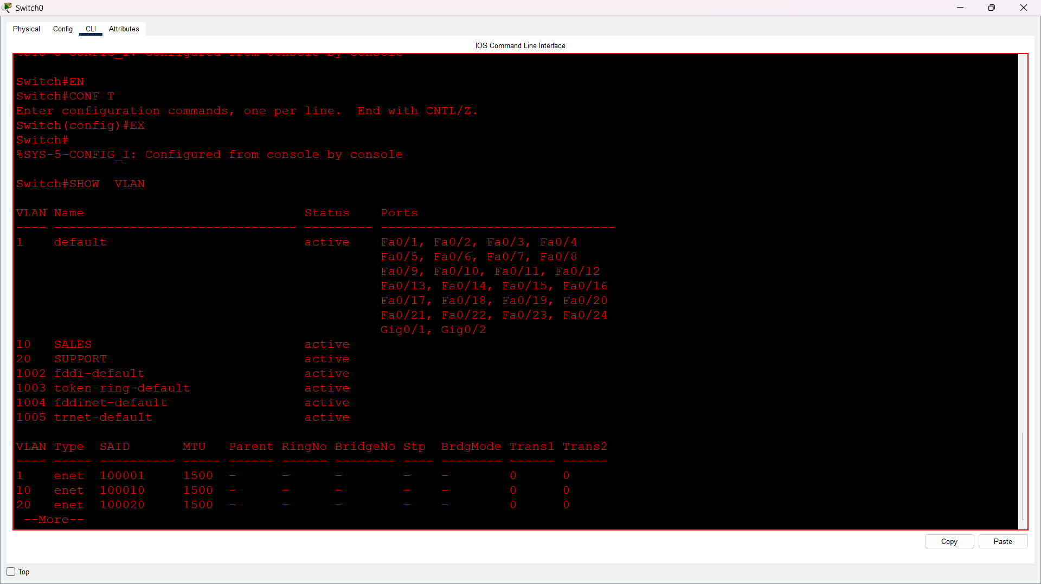

Q2. Assign Switch Ports to Sales and Support VLANs
Objective: Assign three access ports to VLAN 10 and two access ports to VLAN 20, then verify VLAN membership.
Port plan used in this assignment:
VLAN | Name | Assigned Ports
10 | Sales | FastEthernet0/1 - FastEthernet0/3
20 | Support | FastEthernet0/4 - FastEthernet0/5
Step 1: Enter global configuration mode on the switch.
Step 2: Use interface range FastEthernet0/1 - 3 to select three ports together.
Step 3: Configure these ports as access ports and assign them to VLAN 10.
Step 4: Use interface range FastEthernet0/4 - 5 to select two ports together.
Step 5: Configure these ports as access ports and assign them to VLAN 20.
Step 6: Return to privileged EXEC mode and use show vlan brief to verify the VLAN membership.
Commands:
enable
configure terminal
interface range fastEthernet 0/1 - 3
switchport mode access
switchport access vlan 10
exit
interface range fastEthernet 0/4 - 5
switchport mode access
switchport access vlan 20
exit
end
show vlan brief
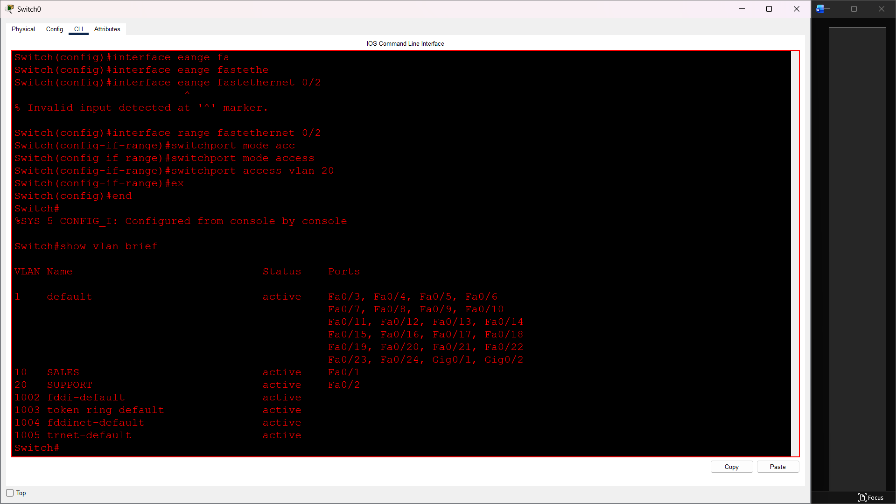

Q3. Connect Two Routers and Configure a Static Route
Objective: Connect two routers, configure interface IP addresses, and add a static route on Router 1 to reach the LAN behind Router 2.
Example addressing used:
Connection / LAN | Device Interface | IP Address | Subnet Mask
R1-R2 Link | R1 G0/1 | 10.0.0.1 | 255.255.255.252
R1-R2 Link | R2 G0/1 | 10.0.0.2 | 255.255.255.252
LAN behind R1 | R1 G0/0 | 192.168.1.1 | 255.255.255.0
LAN behind R2 | R2 G0/0 | 192.168.2.1 | 255.255.255.0

Step 1: Place two routers in Packet Tracer and connect Router 1 to Router 2 using an Ethernet link. Interface names may vary by router model.
Step 2: Configure Router 1's LAN interface as 192.168.1.1/24 and its link to Router 2 as 10.0.0.1/30.
Step 3: Configure Router 2's LAN interface as 192.168.2.1/24 and its link to Router 1 as 10.0.0.2/30.
Step 4: Use no shutdown on every configured router interface.
Step 5: On Router 1, create a static route to the 192.168.2.0/24 LAN using Router 2's next-hop address 10.0.0.2.
Step 6: Use show ip route on Router 1 to verify that the static route appears in the routing table.
Router 1 commands:
enable
configure terminal
interface gigabitEthernet 0/0
ip address 192.168.1.1 255.255.255.0
no shutdown
exit
interface gigabitEthernet 0/1
ip address 10.0.0.1 255.255.255.252
no shutdown
exit
ip route 192.168.2.0 255.255.255.0 10.0.0.2
end
show ip route
Router 2 commands:
enable
configure terminal
interface gigabitEthernet 0/0
ip address 192.168.2.1 255.255.255.0
no shutdown
exit
interface gigabitEthernet 0/1
ip address 10.0.0.2 255.255.255.252
no shutdown
exit
end
Note: If your router uses interfaces such as G0/0/0 and G0/0/1, use those actual interface names instead.

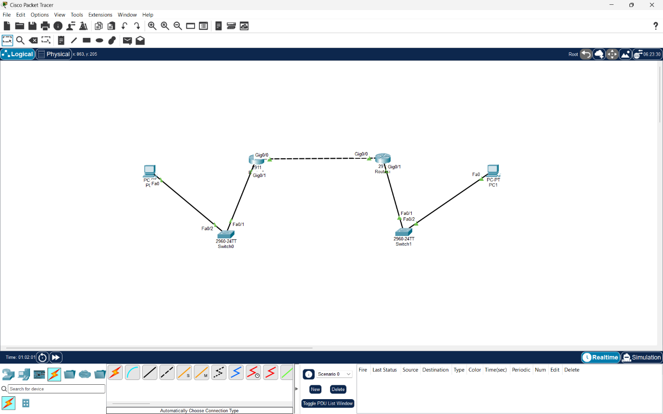

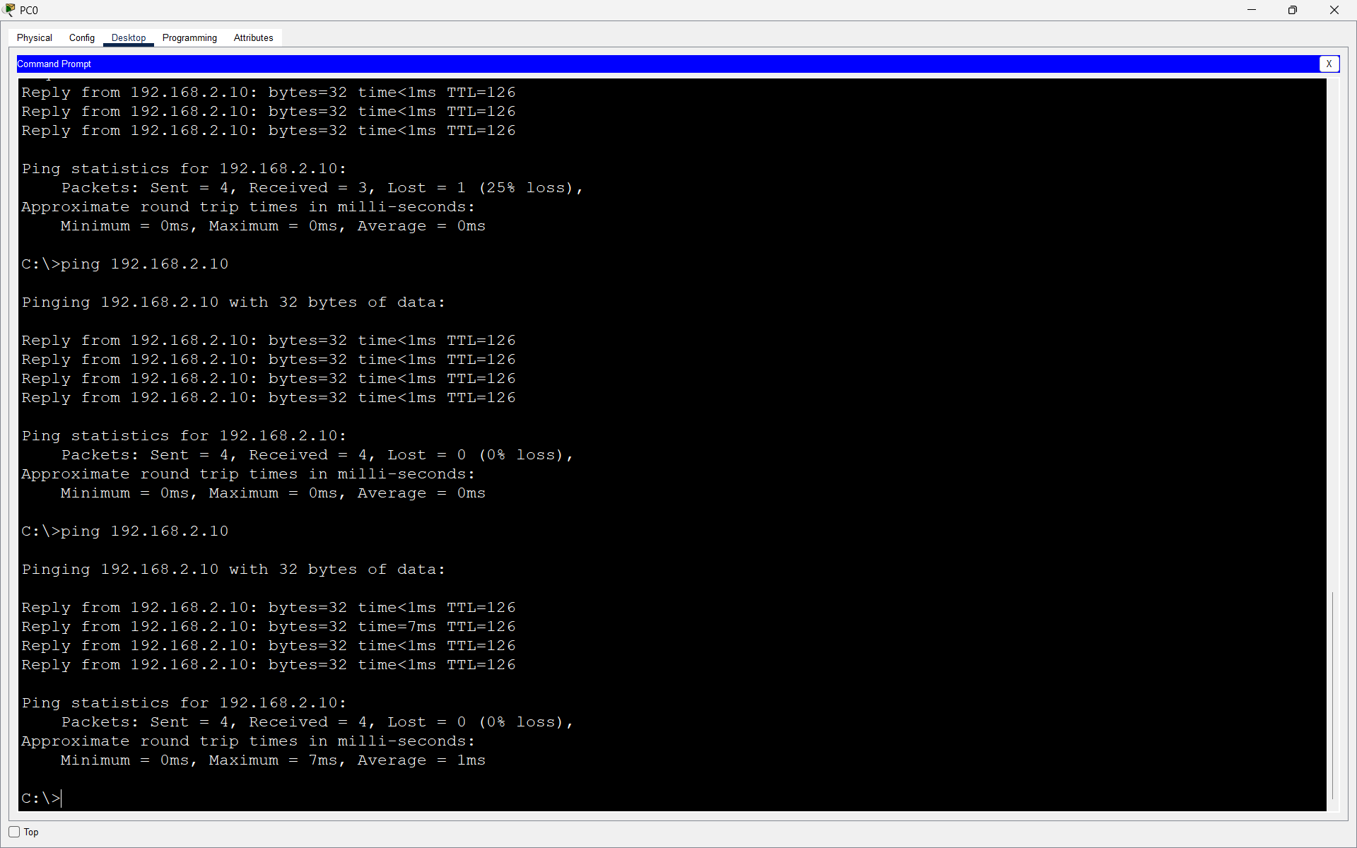

Q4.Ping Between Sales and Support VLANs
Scenario: A PC connected to a Sales VLAN 10 access port tries to ping a PC connected to a Support VLAN 20 access port.
Step 1: Connect a PC to a switch port assigned to VLAN 10 and another PC to a switch port assigned to VLAN 20.
Step 2: Give the Sales PC an address such as 192.168.10.2/24 and the Support PC an address such as 192.168.20.2/24.
Step 3: Try to ping the Support PC from the Sales PC.
Step 4: The ping fails because VLAN 10 and VLAN 20 are separate Layer 2 broadcast domains. A normal Layer 2 switch does not route traffic between different VLANs.
Step 5: To allow communication, configure inter-VLAN routing. This can be done with router-on-a-stick, where a router uses 802.1Q subinterfaces for the VLANs, or by using a Layer 3 switch with switched virtual interfaces (SVIs) and IP routing enabled.
Example ping from the Sales PC:
ping 192.168.20.2
Explanation: VLANs logically separate devices even when they are connected to the same physical switch. Communication between different VLANs requires a Layer 3 device to route packets from one VLAN/subnet to the other.

Result
VLAN 10 (Sales) and VLAN 20 (Support) were created successfully, switch ports were assigned to the required VLANs, and VLAN membership was verified. Two routers were configured with IP addresses and Router 1 was given a static route to the LAN behind Router 2. A ping between different VLANs failed without inter-VLAN routing, demonstrating VLAN isolation.
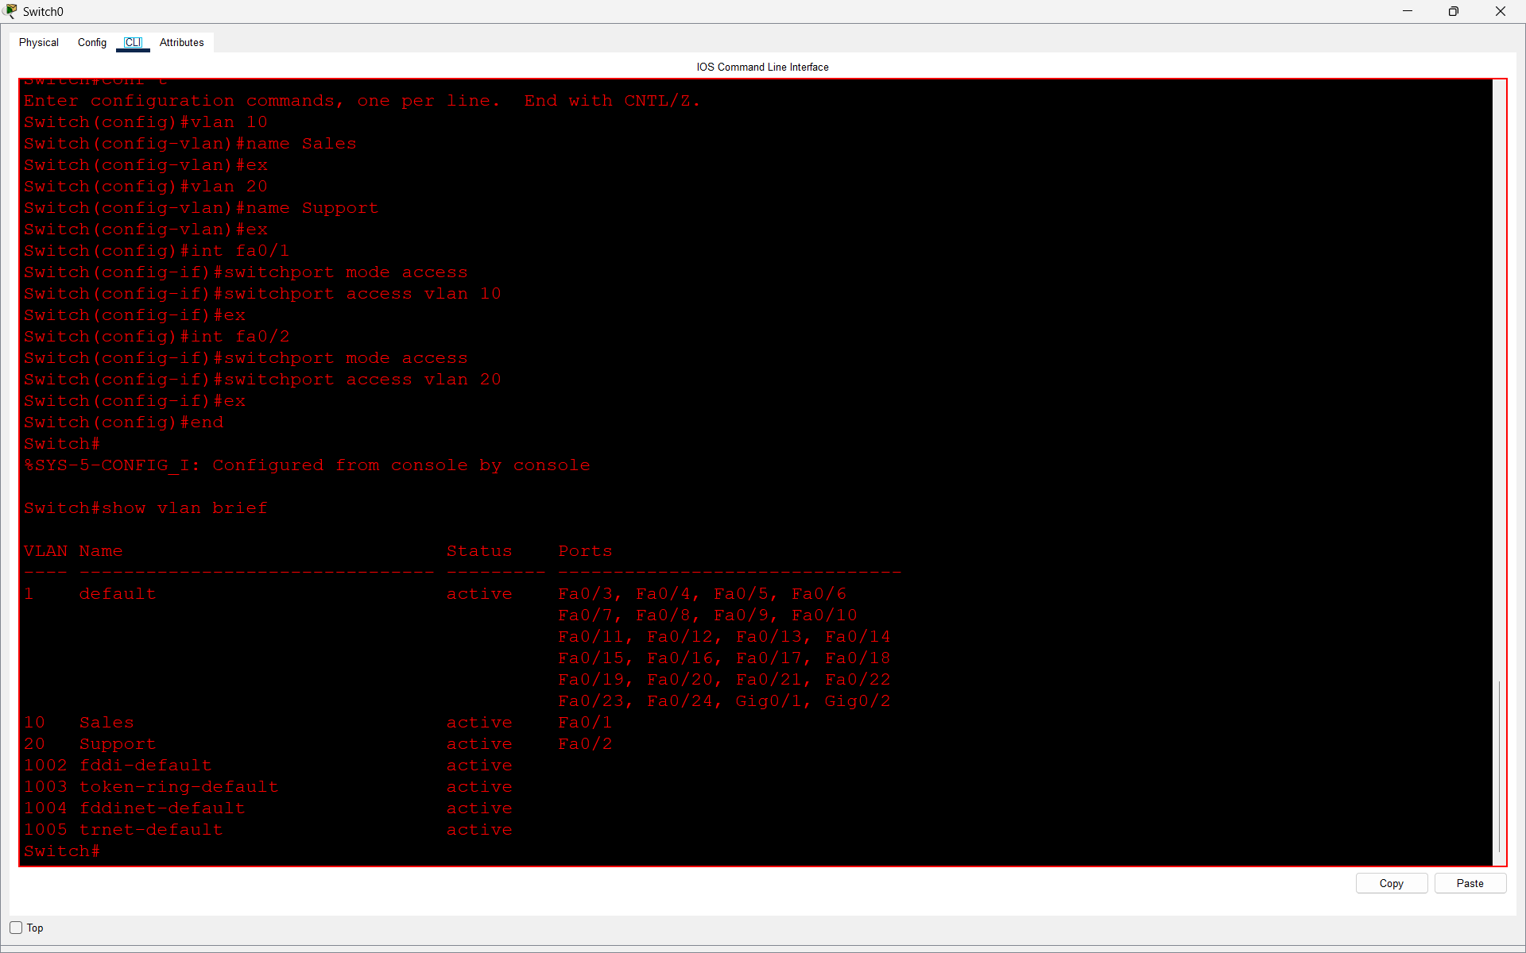
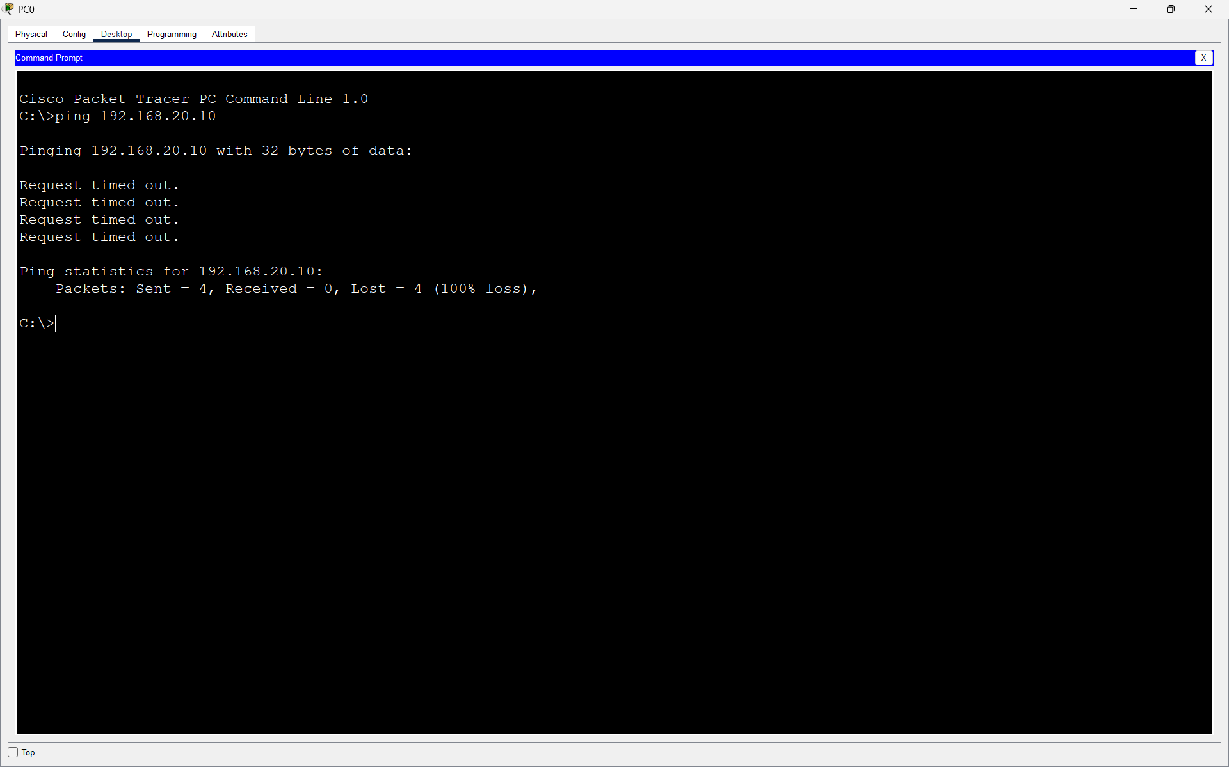

Conclusion
This practical demonstrates VLAN creation, access-port assignment, VLAN verification, router interface configuration, static routing, and the need for router-on-a-stick or a Layer 3 switch when communication between separate VLANs is required.

